Data Science HW5

R07921010 余奇安

1. I organize data as the following

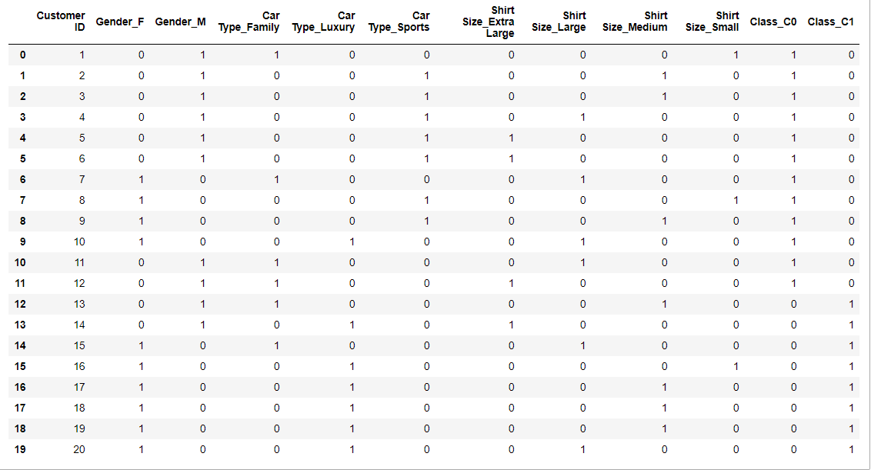

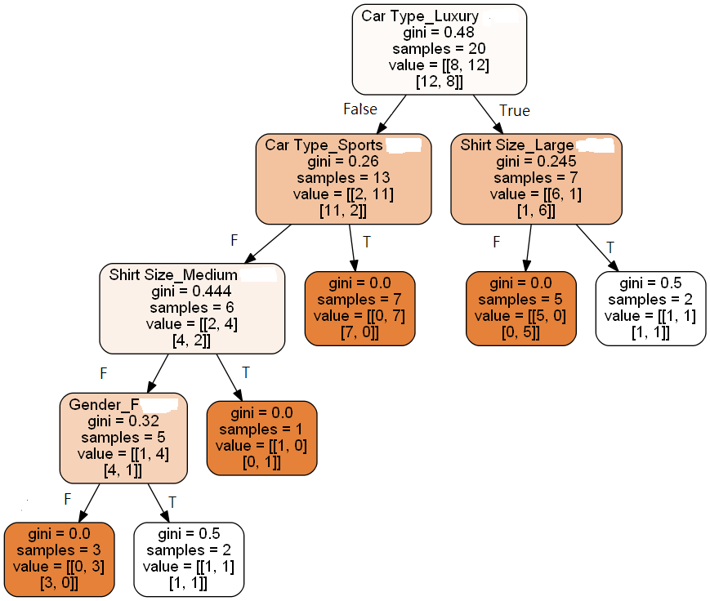

2.Naive Bayer Classifier

(Gender=F, Car Type=Luxury, Shirt Size=Large)

Compare the Probability of:

P(C1 | F, Luxury, Large) and P(C0, | F, Luxury, Large)

$$P\left(C1 | F,Luxury, Large\right)= \frac{P(F,Luxury, Large|C1)P(C1)}{P(F,Luxury, Large)}$$

$$P\left(C0 | F,Luxury, Large\right)= \frac{P(F,Luxury, Large|C0)P(C0)}{P(F,Luxury, Large)}$$

Assume gender, Car Type, Shirt Size are independent attribute,

$$P\left(F,Luxury, Large | C0\right)P\left(C0\right)=P\left(F | C0\right)*P\left(Luxury | C0\right)*P\left(Large | C0\right)*P\left(C0\right)$$

$=\frac{0.2}{0.6}*\frac{0.05}{0.6}*\frac{0.2}{0.6}*0.6= \frac{1}{90}=0.0111$

$$P\left(F,Luxury, Large | C1\right)P\left(C1\right)=P\left(F | C1\right)*P\left(Luxury | C1\right)*P\left(Large | C1\right)*P\left(C1\right)$$

$=\frac{0.3}{0.4}*\frac{0.3}{0.4}*\frac{0.1}{0.4}*0.4= \frac{9}{160}=0.05625$

$$→classify to C1$$

3.SVM

Positive examples, y = 1: (4, 3), (7, 2), (4,8)

Negative examples, y = -1: (2, 1), (2, -1), (-1, 3), (-1, -2)

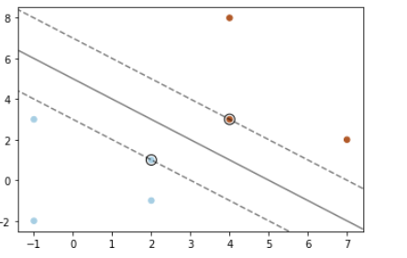

The support vector are (2,1) and (4,3)

y = wx + b

w = ${[0.5 0.5]}^{T}$, b = -2.5

The hyper plane is shown as figure.